Region 3 Learning Collaborative CQI Tools
“Affinity Diagram” Table Top Exercise
Definition:
An Affinity Diagram is commonly used when the problem (or issue) is complex and hard to understand and/ or the problem seems unclear or overwhelming. If the problem is fairly well defined, teams can use a cause and effect tool (fishbone diagram). The Affinity Diagram is intended to be a brainstorming exercise to build consensus, identify unlikely causes or solutions, and allow full team participation. It is particularly useful for collecting information data (ideas, issues, solutions, problems) from all participants, organizing the information into logical categories based on relationships, and presenting the information to stakeholders.
Directions:
Select a specific/ unique DSRIP project at your table and a facilitator.
- For the selected project, identify and clearly state a possible barrier to success or problem that must be overcome. It is useful to state the problem in the form of a question such as, “What are the problems associated with our expansion?”
- Next, brainstorm ideas concerning the issue statement. The simplest and most effective method of brainstorming is for each participant to write a SINGLE idea associated with the problem/ issue on a sticky note, in silence. There is no verbal exchange of ideas at this point. Participants should continue to brainstorm ideas and write each unique idea on a separate sticky note. Each participant may generate 10-20+ sticky notes.
- The facilitator collects all of the sticky notes and reads each one out loud and places it randomly on the wall. Participants are encouraged to write additional ideas as they surface during this period. Discussion can take place regarding clarification of each idea and/ or to generate new ideas.
- After all the sticky notes, and new notes, are placed randomly on the wall, participants begin to organize or cluster ideas. All participants are invited to the wall to “move” or cluster the sticky notes. Participants should look for ideas that seem to be related in some way and place them side by side. It is okay to have “loners” that don’t seem to fit a group. It is also okay to move a note someone else has already moved. If a note seems to belong in two groups, make a second note. (This takes times… be patient!)
- Once sticky notes have been clustered, the facilitator works with the team to determine a general category or topic for the cluster. Each cluster is labeled with the agreed upon categorical name.

Worksheet:
Using the figure below as a reference for what your end product might look like, complete an Affinity Diagram.
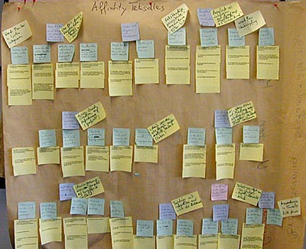
Participant Ideas
Categories

