Region 3 Learning Collaborative CQI Tools
“Project Charter” Table Top Exercise
Definition:
A project charter is a statement of the scope, objectives, and participants in a project. It provides a preliminary delineation of roles and responsibilities, outlines the project objectives, identifies the main stakeholders, and defines the authority of the project manager.
The purpose of the project charter is to document:
- Reasons for undertaking the project
- Objectives and constraints of the project
- In-scope and out-of-scope items
- Directions/ Accountability concerning the solution
- Communication of CQI initiative, current state and future state
- Delineation of expected (and measurable) project benefits and outcomes.
- High level budget and spending authority (possibly).
Directions:
Select a specific/ unique DSRIP project at your table. For that project, brainstorm the following elements of a project charter and fill out the worksheet in the end:
- Problem Statement: In a single sentence, capture the essence of the problem. Be sure the problem is stated in measurable terms.
- Project Scope: Identify the start and stop points for the project. Remember you want to improve the “problem” in 3-6 months, so keep the scope achievable. This may include specifying the location, target patient population, specific task(s), unique department, etc.
- Measures of Success: How will your team know you have improved the problem? Success must be quantifiable metrics. Consider rates, utilization, volume, time, satisfaction, money, etc.
- Meeting Expectations: Create a reasonable timeframe for both team meetings and the project completion.
- Identify Team Roles & Responsibility: Specify the team leader (calls the meetings, sets the agenda, keeps the team moving ahead). Identify a team champion (senior leader who can approve financial resource needs, assure adequate time away from routing tasks for team members, support and communicate the implementation and outcomes)

Cohort Group Charter
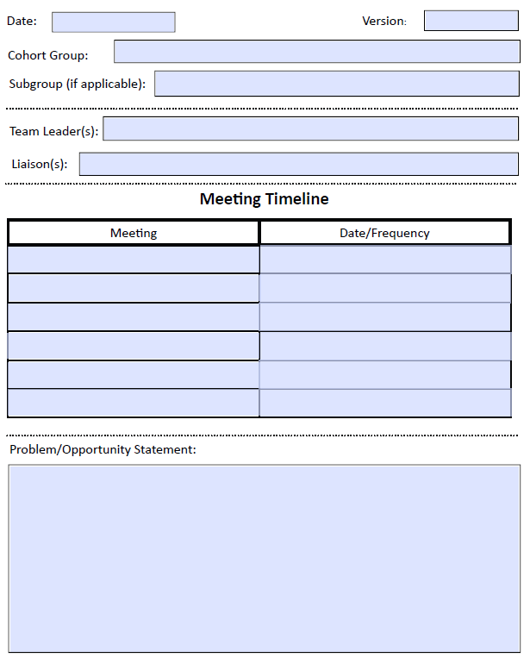
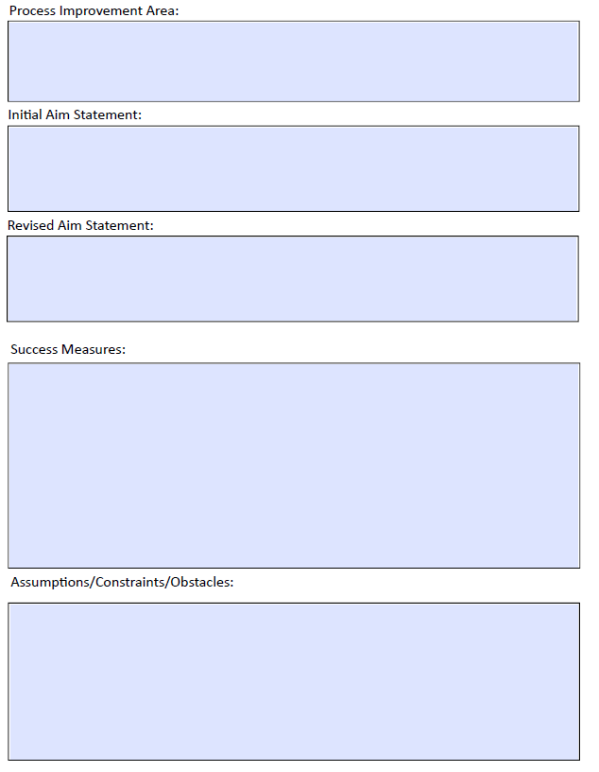

Source: Wikipedia http://en.wikipedia.org/wiki/Project_charter

