Region 3 Learning Collaborative CQI Tools
“Value Stream Mapping” Table Top Exercise
Definition:
Value Stream Mapping (VSM) is a tool used to provide a common understanding of current reality. It can be tedious for the subject matter expert(s) but the process is very, very useful for the participants. It opens the door for discussion on why things are done a specific way and paves the way for improvement ideas. VSM allows the team to “see” opportunities for improvement. The identified process steps allow the team to begin to formulate a data collection needs assessment and plan.
VSM differs from a flowchart because it is at a higher level. It tends to be at a higher level (5-10 boxes) rather than numerous process maps. It includes material, patient information, and documentation flow. A flowchart typically depicts very concrete steps required to complete a defined task/ treatment.
Directions:
Select a specific/ unique DSRIP project at your table. Use a flipchart page, sticky notes (they are easily movable) and markers to capture your process steps.
1. Start by identifying the process customer. List each step which show the flow of information and actions required to fulfill the customer need. For example a referral, follow up appointment, and phone call for insurance verification are all process steps included in the VSM. Printing the referral and interfacing with the IT system are informational documents that should be included as inputs to the process.
2. Include (estimated) times for each process step and/ or information flow. This might include information about wait times, travel times, etc. These potentially non-value added process steps are important to identify. Quantifying the entire process based on time, people, and cost allows you to both identify opportunities for improvement and demonstrate successes.

Worksheet:
Using a flipchart page and the examples below, construct a VSM.
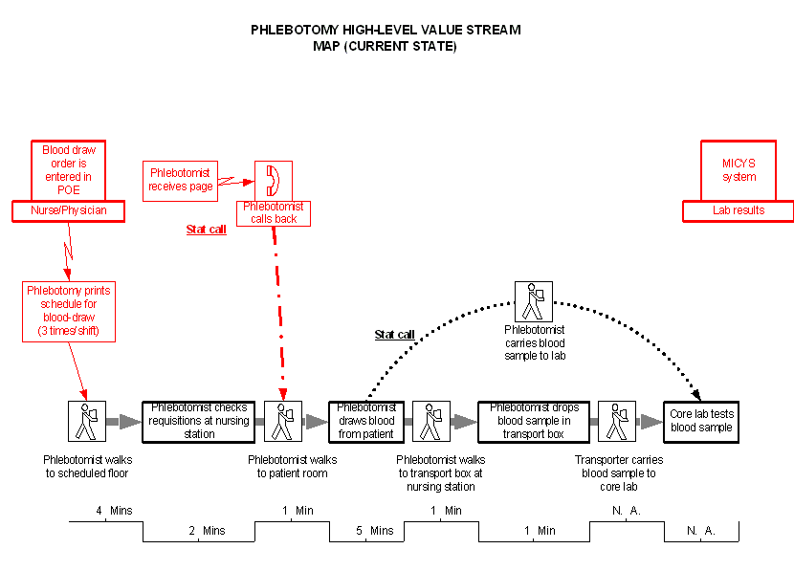
Process Steps for customer (phlebotomist)
Note the process times are listed here.
Information flows for the process.

