Southeast Texas Regional Healthcare Plan – DSRIP Workgroup
Scope Document

The Harris County Hospital District (HCHD), in collaboration with the Texas Health & Human Services Commission (HHSC), welcomes you to the Waiver 1115 Delivery System Reform Incentive Payments (DSRIP) process. HCHD has been deemed a Regional Healthcare Partner (RHP) (aka “Anchor Hospital”) and will work closely with all organizations to ensure collaboration of strategic efforts, facilitate constructive meetings in order to outline initiatives and provide ongoing updates, and serve as a single point of contact during the development of the DSRIP initiatives. HCHD is eager to work with stakeholders to outline a comprehensive DSRIP plan that addresses the needs of our communities during such a dynamic healthcare transformation.

The engagement of your organization is critical to the success of the project and we ask for your innovative ideas as well as constructive feedback as we begin the workgroup process. Health Management Associates (HMA) has the robust task of overseeing the workgroups to make certain deliverables are produced according to the HHSC timelines. The HMA team brings years of healthcare experience to such a dynamic group of individuals and will work closely with you throughout the upcoming months.

The HCHD & HMA teams are here to be of assistance and this document will provide a summary of the workgroup scope to establish expectations and timelines. A complete listing of the workgroup categories is included as an attachment to this document.

Guiding Principles:
- The DSRIP workgroups shall work collaboratively to identify innovative healthcare initiatives to improve access to care, quality of care, cost of care, and the overall health of our community.
- Plans identified should represent a regional healthcare transformation to address the current & anticipated needs of the consumer.
- Each workgroup has a defined category and will work within the parameters of the continuum of care for the category.
- Stakeholders involved should discuss functions relating to healthcare as well as environmental & societal factors relating to the category for overall improvement ideas.
- Principles should be inclusive of:
  - Infrastructure development – foundation for delivery system transformation through the investment in technology, tools & human resources
  - Program innovations & redesign – piloting, testing & replicating innovative care models
  - Quality improvements – requires hospitals to implement interventions to achieve clinical improvement
  - Population focused improvements – requires hospitals to report on a predetermined set of measures to include: patient experience, coordination of care, prevention, and health outcomes.

Expected Deliverables:
- Each workgroup, with the assistance of HMA, will outline recommendations that have been fully vetted by all members.
- Pending the HHSC State Menu (draft published April 6, 2012) & RHP plan template, each initiative could include such items as:
  - Initiative purpose statement
  - Overall goals with desired conceptual outcomes
  - Community assessment to include target patient population, demographics, insurance coverage, healthcare infrastructure, disease profile, etc.
  - SWOT analysis (Strengths / Weakness / Opportunities / Threats)
  - Core challenges of the initiative
  - Pre-determined outcome measures that define annual success of the project. (The measurements will determine the payment possibilities for all organizations involved.). The State DSRIP Menu will have specific metrics for all categories for all to reference.
  - Anticipated cost categories of expense
  - Potential organizations involved & primary point of contact
- State DSRIP menu categories include:
  - Category I – Infrastructure Development
  - Category II – Program Innovation & Redesign
  - Category III – Quality Improvements (mandatory)
  - Category IV – Population-based Improvements

- All RHP initiatives must align with a State DSRIP Menu initiative. (http://www.hhsc.state.tx.us/1115-docs/DSRIP-Menu-DRAFT.pdf)
- The intent of the workgroup is to outline the concept, understanding that a number of the items listed above will be refined by the entities that are responsible for the IGT of the project.
- The workgroup initiatives will be prioritized through an online survey process in June 2012.
- Each organization for each workgroup will be allowed to submit one response through a survey control function.
- Prioritized initiatives will be reviewed by the Regional Advisory Council (RAC), IGT entities, and HCHD’s Board of Managers for the submission to the state for approval.

Timeline:
- Regional Advisory Council (RAC) meetings will provide progressive updates:
    - March 21, 2012
    - April 18, 2012
    - May 16, 2012
    - June, July & August meetings to be scheduled
- July 1, 2012 - DSRIP plans due to HCHD from workgroups
- July – August 2012 – RHP preparation & planning with the Regional Advisory Council, IGT entities & HCHD Board of Managers
- September 1, 2012 – Urban & Rural plans due to HHSC
- October 1, 2012 – Urban plans due to CMS from HHSC

Communication / Contact Information:

Harris County Hospital District
David Lopez, CEO (David_Lopez@hchd.tmc.edu / 713-566-6403
King Hillier, VP Public Policy & Govt Relations (Robert_Hillier@hchd.tmc.edu / 713-566-6425)
Beth Cloyd, EVP Clinical Operations (Beth_Cloyd@hchd.tmc.edu / 713-566-6821)
Amanda Simmons, Assoc Administrator – Health System Strategies (Amanda_Simmons@hchd.tmc.edu / 713-566-6405)

Health Management Associates
Linda Wertz (lwertz@healthmanagement.com / 512-473-2626)
Diane Longley (dlongley@healthmanagement.com / 512-473-2626)
Lynne Fagnani (lfagnani@healthmanagement.com / 202-785-3669)

The Southeast Texas Regional Healthcare Planning website http://www.setexasrhp.com will serve as the primary source of communication & resources for the Region # 3 RHP. All meeting notes & presentations as well as ongoing updates can be found on the site.

Region #3 – HCHD RHP Workgroups
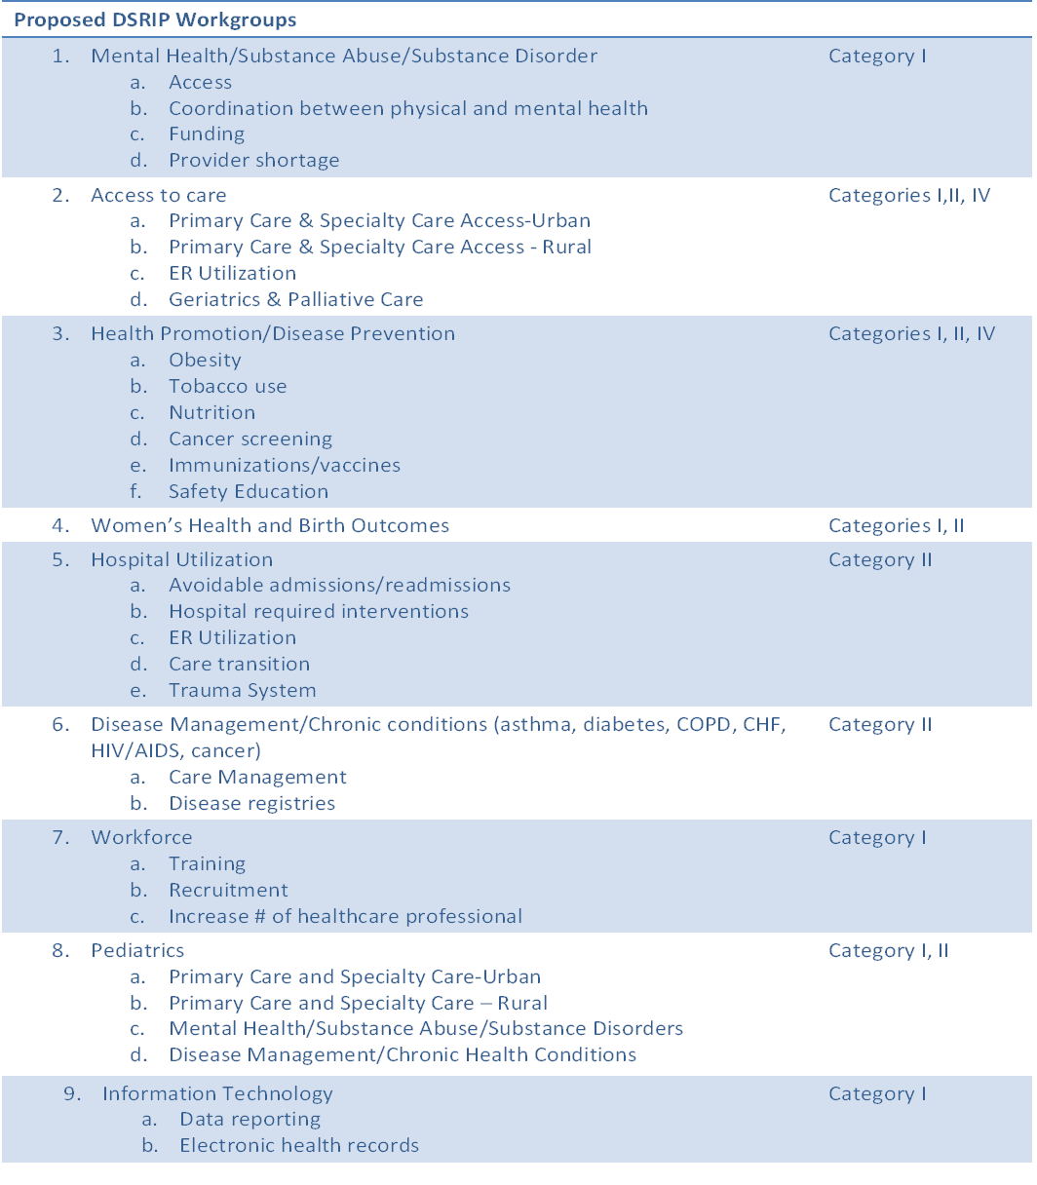

Region #3 – Workgroup Schedule (Updated 04/12/2012)

Workgroup | Date | Time | Location
Access to Care | March 28, 2012  April 9, 2012  May 9, 2012 | 5:00 to 7:00 p.m. | Marriott Medical Center, 6580 Fannin, Houston TX
Disease Management/Chronic Conditions | March 20, 2012  April 17, 2012  May 14, 2012 | 3:00 to 4:45 p.m. | Health Museum – 1515 Herman, Houston, TX
Health Promotion/Prevention | March 19, 2012  April 16, 2012  May 15, 2012 | 5:00 to 6:45 p.m.  5:00 to 6:45 p.m.  3:00 to 4:45 p.m. | Health Museum – 1515 Herman, Houston, TX
Hospital Utilization | March 19, 2012  April 16, 2012  May 14, 2012 | 3:00 to 4:45 p.m. | Health Museum – 1515 Herman, Houston, TX
Information Technology | March 19, 2012  April 16, 2012  May 14, 2012 | 3:00 to 4:45 p.m. | Health Museum – 1515 Herman, Houston, TX
Mental Health/Substance Abuse | March 28, 2012  April 9, 2012  May 9, 2012 | 5:00 to 7:00 p.m. | Marriott Medical Center, 6580 Fannin, Houston TX
Pediatrics | March 20, 2012  April 17, 2012  May 15, 2012 | 5:00 to 6:45 p.m. | Health Museum – 1515 Herman, Houston, TX
Women’s Health/Birth Outcomes | March 19, 2012  April 16, 2012  May 15, 2012 | 5:00 to 6:45 p.m. | Health Museum – 1515 Herman, Houston, TX
Workforce | March 20, 2012  April 17, 2012  May 15, 2012 | 3:00 to 4:45 p.m. | Health Museum – 1515 Herman, Houston, TX

Regional Advisory Council (RAC)
March 21, 2012 4:00 – 6:00 p.m. Health Museum – 1515
Herman
April 18, 2012 4:00 – 6:00 p.m. Health Museum
May 16, 2012 4:00 – 6:00 p.m. Health Museum
*Additional RAC meetings to be scheduled for June – October.

