To access the Employee Wellness page:
From the Home page in Sharepoint, click on the PeopleSoft Portal link in the Employee Tools section:
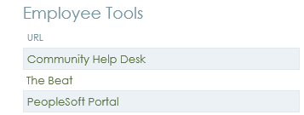
Select Citrix Portal Login link in the Employees section:
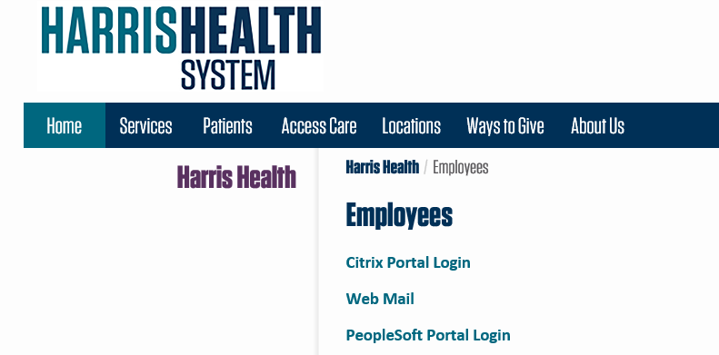
Login to Citrix.
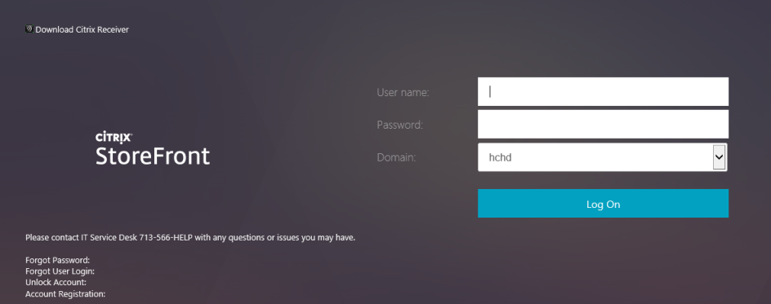
Select Healthy@Harris Employee Wellness page.
